Software Requirements Specification

for

Nudge
Version 1.0 approved
Prepared by: Aidan Carty, Sam Van, Nicholas McHugh, Nathan Wheeler, Logan Madden
Team: Crab
10/7/25
Table of Contents
Table of Contents ii
Revision History ii
1. Introduction 1
1.1 Purpose 1
1.2 Document Conventions 1
1.3 Intended Audience and Reading Suggestions 1
1.4 Product Scope 1
1.5 References 1
2. Overall Description 2
2.1 Product Perspective 2
2.2 Product Functions 2
2.3 User Classes and Characteristics 2
2.4 Operating Environment 2
2.5 Design and Implementation Constraints 2
2.6 User Documentation 2
2.7 Assumptions and Dependencies 3
3. External Interface Requirements 3
3.1 User Interfaces 3
3.2 Hardware Interfaces 3
3.3 Software Interfaces 3
3.4 Communications Interfaces 3
4. System Features 4
4.1 System Feature 1 4
4.2 System Feature 2 (and so on) 4
5. Other Nonfunctional Requirements 4
5.1 Performance Requirements 4
5.2 Safety Requirements 5
5.3 Security Requirements 5
5.4 Software Quality Attributes 5
5.5 Business Rules 5
6. Other Requirements 5
Appendix A: Glossary 5
Appendix B: Analysis Models 5
Appendix C: To Be Determined List 6

Revision History
Name | Date | Reason For Changes | Version

Introduction

Purpose
<Identify the product whose software requirements are specified in this document, including the revision or release number. Describe the scope of the product that is covered by this SRS, particularly if this SRS describes only part of the system or a single subsystem.>

This document contains all the detailed software requirements of version 1 of our Nudge app. This SRS helps us focus on the major functionality of our app such as our question asking features and how they are interacted with along with our socially focused features such as public questions or work boards with anonymous possibility.

Document Conventions
<Describe any standards or typographical conventions that were followed when writing this SRS, such as fonts or highlighting that have special significance. For example, state whether priorities for higher-level requirements are assumed to be inherited by detailed requirements, or whether every requirement statement is to have its own priority.>

Naturally as the document was given the size 11 Arial was used for most of the writing, and the sections are separated through numbers with decimal subsections. The sections also used a large font size for the headings and subheadings to make them stand out more. This way, specific sections can be easier to find for anybody reading through the document. When regarding our functional and non functional requirements we also separated them with the FREQ-1.1, and -REQ-1 format given in the document as well.

Intended Audience and Reading Suggestions
<Describe the different types of reader that the document is intended for, such as developers, project managers, marketing staff, users, testers, and documentation writers. Describe what the rest of this SRS contains and how it is organized. Suggest a sequence for reading the document, beginning with the overview sections and proceeding through the sections that are most pertinent to each reader type.>

This document is mostly for the development team but also can be important to investors and marketers to envision or promote a product. Naturally developers and testers will focus on the overall idea of the app, and then how to program it to our requirements in sections 4 and 5. On the other side of things, investors can focus on sections 2,4 and 5 to gather an understanding of what is being created and why it's important. Then, for marketing or promotional purposes, sections 2,3,4,5 are key when regarding what it's supposed to look like and appear to users, and how that contributes to the goals of our app.

Product Scope
<Provide a short description of the software being specified and its purpose, including relevant benefits, objectives, and goals. Relate the software to corporate goals or business strategies. If a separate vision and scope document is available, refer to it rather than duplicating its contents here.>

The software for our nudge app imagines an app where students, employees, or hobbyists alike can interact with a platform online that allows them to communicate with strangers or those they may work with about any problems they may encounter while developing a product. It will also allow team members to communicate with one another about any projects they may be working on. Using friendly looking interfaces, possibility for anonymous usership, our app plans to stop people from wasting time, or struggling to find help by having it quickly and easily accessible.

References
<List any other documents or Web addresses to which this SRS refers. These may include user interface style guides, contracts, standards, system requirements specifications, use case documents, or a vision and scope document. Provide enough information so that the reader could access a copy of each reference, including title, author, version number, date, and source or location.>

Overall Description

Product Perspective
<Describe the context and origin of the product being specified in this SRS. For example, state whether this product is a follow-on member of a product family, a replacement for certain existing systems, or a new, self-contained product. If the SRS defines a component of a larger system, relate the requirements of the larger system to the functionality of this software and identify interfaces between the two. A simple diagram that shows the major components of the overall system, subsystem interconnections, and external interfaces can be helpful.>

The Nudge app is a brand new creation thought up by Team Crab. We don't plan on redesigning anything, but to reinvent previous solutions to help people in a fresh way. We take on the idea of a web or mobile app that can help new developers like us build confidence and rates of success when help seeking, and general work related interactions.

Product Functions
<Summarize the major functions the product must perform or must let the user perform. Details will be provided in Section 3, so only a high level summary (such as a bullet list) is needed here. Organize the functions to make them understandable to any reader of the SRS. A picture of the major groups of related requirements and how they relate, such as a top level data flow diagram or object class diagram, is often effective.>

- Anonymous Usership

- User Profiles

- Q & A pages, with search ability

- Public question boards(generic or specific)

- User interaction(messages, upvote/downvote, moderation/reporting)

- User and corporate teams

User Classes and Characteristics
<Identify the various user classes that you anticipate will use this product. User classes may be differentiated based on frequency of use, subset of product functions used, technical expertise, security or privilege levels, educational level, or experience. Describe the pertinent characteristics of each user class. Certain requirements may pertain only to certain user classes. Distinguish the most important user classes for this product from those who are less important to satisfy.>

Professional Development teams: These teams are our primary focus, with hope that our app can act as an effective space for every role within the team when developing projects.
Dev: The people who directly create the code for any projects, our app would assist them in working cooperatively and allow them to receive any help they may require. Our app as a whole would help developers, though the most important features would be the teams where they can efficiently work with the other developers on their project and the question boards where they can ask any questions they have or search for solutions directly.
PM: The project managers who overlook the project as a whole and how well the developers are progressing. The most important features for these users would be the teams and chat features, allowing them to directly interact with the developers and see which parts of a project may need more attention or who may need help.

Testers: The people who test the finished product. The chat features would allow them to directly communicate any issues they encounter with the developers and the question boards could be used as an effective tool to start discussions on how to resolve certain flaws.

Junior Dev: The newer developers within a team are the main reason why we added some features that other apps lack. The anonymous users feature would create an extra layer of security, allowing newer developers to ask any questions they may have without fear of judgement. The public question boards could also be effective tools for finding answers to any questions they may have.

Students: The public discussion boards would be an effective tool for any students still learning development to answer any questions they may have or roadblocks they may encounter. The chatting features would also allow them to directly connect with potential future employers, making it easier to transition from an academic setting to the professional world
Hobby Developers: The various discussion boards would allow hobby developers to answer any questions they may have and connect with other developers who may have similar interests. Our message features would then give them an avenue to connect with those developers and allow them to possibly work cooperatively or assist each other in the future.

Operating Environment
<Describe the environment in which the software will operate, including the hardware platform, operating system and versions, and any other software components or applications with which it must peacefully coexist.>

Our app will be a web application that can be accessed through any browser, such as chrome or firefox. It should be easily accessible to anybody with a working device and an internet connection to ensure that users can go on and receive any help they may need as swiftly as possible.

Design and Implementation Constraints
<Describe any items or issues that will limit the options available to the developers. These might include: corporate or regulatory policies; hardware limitations (timing requirements, memory requirements); interfaces to other applications; specific technologies, tools, and databases to be used; parallel operations; language requirements; communications protocols; security considerations; design conventions or programming standards (for example, if the customer’s organization will be responsible for maintaining the delivered software).>

There are a couple things to consider when thinking about design and implementation constraints. Firstly the nature of the course, so having to work within the semester, while focusing on other classes is a large constraint on this project. Next is the limit of our developmental abilities as a team, though I am confident we can build a functioning successful project, our skills aren't exactly on par to compete with massive companies with large teams and funding. Along with that, our team can only utilize what we have learned so far in this class, so we are unable to use any languages we may be more comfortable with. Then, working with things such as protection and cybersecurity is also something that could be beyond the scope of our skills as a team, which would require further teaching. Then with our conflicting schedules it is hard work to meet often and keep track of each other's work.

User Documentation
<List the user documentation components (such as user manuals, on-line help, and tutorials) that will be delivered along with the software. Identify any known user documentation delivery formats or standards.>

Within our app, we will include a help page outlining the various uses of our app and how you can access them. This will be delivered through text and images showing the process of doing various tasks, such as posting a question or joining a group. We will also have a frequently asked questions page for any questions that have been asked multiple times within our app, with one page being for general questions and another for questions specific to our app.

Assumptions and Dependencies
<List any assumed factors (as opposed to known facts) that could affect the requirements stated in the SRS. These could include third-party or commercial components that you plan to use, issues around the development or operating environment, or constraints. The project could be affected if these assumptions are incorrect, are not shared, or change. Also identify any dependencies the project has on external factors, such as software components that you intend to reuse from another project, unless they are already documented elsewhere (for example, in the vision and scope document or the project plan).>

Assumed factors that could affect the SRS statements are things relative to data security and user interaction. We must assume the person can access the application and enter their information without worry. Ideally this will need to be verified through an email or username and require it for job related interactions. We need to be sure the user can safely access and interact with the site and that when they do the data can be stored safely elsewhere.

External Interface Requirements

User Interfaces

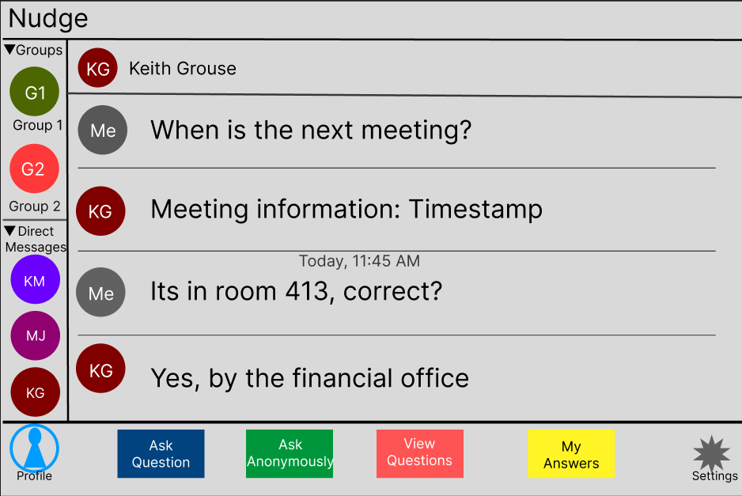
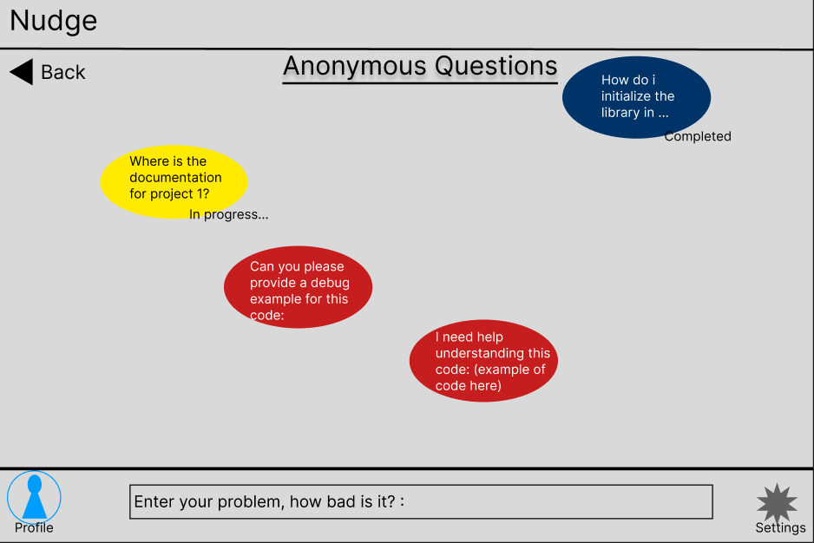
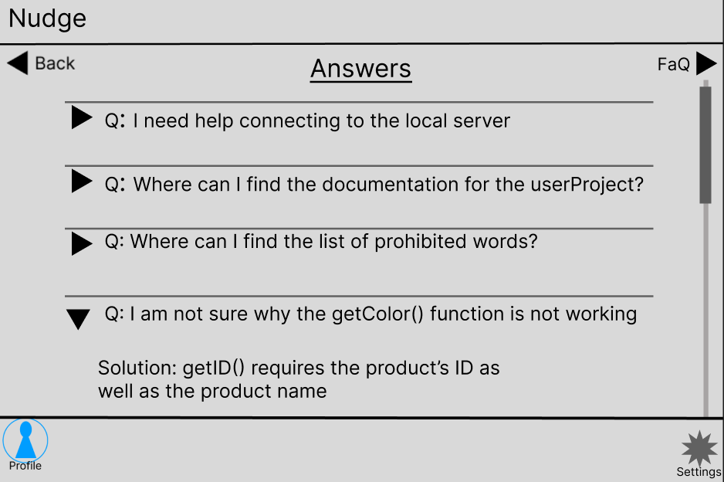
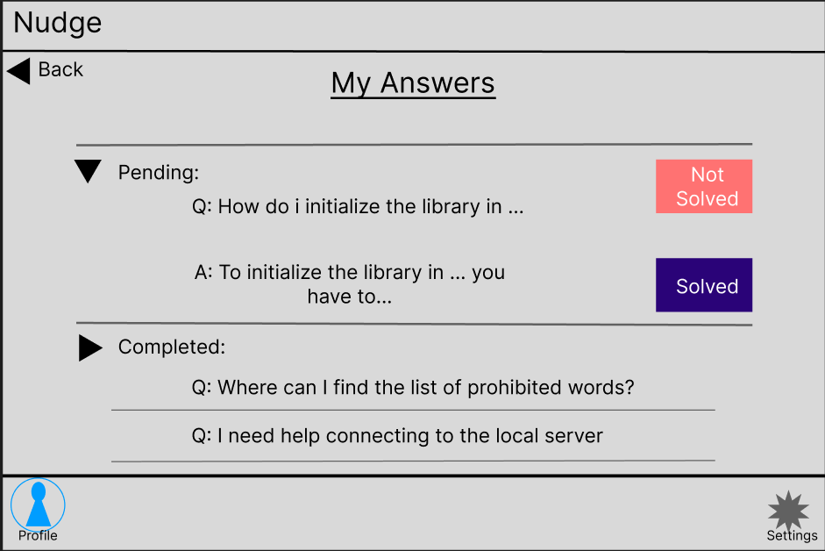

Hardware Interfaces
<Describe the logical and physical characteristics of each interface between the software product and the hardware components of the system. This may include the supported device types, the nature of the data and control interactions between the software and the hardware, and communication protocols to be used.>

Software Interfaces
<Describe the connections between this product and other specific software components (name and version), including databases, operating systems, tools, libraries, and integrated commercial components. Identify the data items or messages coming into the system and going out and describe the purpose of each. Describe the services needed and the nature of communications. Refer to documents that describe detailed application programming interface protocols. Identify data that will be shared across software components. If the data sharing mechanism must be implemented in a specific way (for example, use of a global data area in a multitasking operating system), specify this as an implementation constraint.>

Communications Interfaces
<Describe the requirements associated with any communications functions required by this product, including e-mail, web browser, network server communications protocols, electronic forms, and so on. Define any pertinent message formatting. Identify any communication standards that will be used, such as FTP or HTTP. Specify any communication security or encryption issues, data transfer rates, and synchronization mechanisms.>

System Features
<This template illustrates organizing the functional requirements for the product by system features, the major services provided by the product. You may prefer to organize this section by use case, mode of operation, user class, object class, functional hierarchy, or combinations of these, whatever makes the most logical sense for your product.>

Asking questions anonymously
    - The user should be able to write into a text box a question and then post that text to a group on the app where all other users in that group can see and interact with the text. The other normal users should not be able to see who posted the text. High priority.
    - Upon selecting a group, a text box should be available to type in. After typing they can click a button or use “enter” on their keyboard to add their question into the group question board.

FREQ-1.1:The application should display and allow users to select groups to interact with from their profile.
FREQ-1.2:The application should allow users to add groups to their profile
FREQ-1.3:The application should ignore empty text boxes when questions are attempted to be sent
FREQ-1.4:The application should display an interactable textbox
FREQ-1.5:The application should allow users to post the text in the textbox to a group’s question board.
FREQ-1.6:The application should display an option to turn on or off anonymous status when posting questions
FREQ-1.7:The application should default the anonymous status to being “on” whenever a new question is drafted
FREQ-1.8:The application should display all questions from all users within a group to all users in the same group
FREQ-1.9:The application should allow users to delete their own questions
FREQ-1.10:The application should allow moderators to delete other user questions
FREQ-1.11:The application should allow users to comment on questions posted in a group question board the user has access to.
FREQ-1.12:The application should allow the user who created a question to choose a comment from the comments from their question as the “solution that worked to solve their issue”
FREQ-1.13:The application should find questions that are frequently asked and save them to a special location on the group’s question board.
FREQ-1.14:The application should allow users to create a group.
FREQ-1.15:The application should set group creators as the moderator of the group they created.
FREQ-1.16:The application should allow group creators to assign other users in the group to the role of moderator of that group.
  - User Profiles
    - When opening the application for the first time, the user should be prompted to sign in or to create a new account. This account should be created with an username and password and contain the following information: The users “name”,the users groups, the users questions. The profile may contain some more information such as the user's bio, and “score”. This is a medium priority feature.
    - When the application is opened with no account logged in, the application will display an option to either sign in or create an account. Once logged in the application will display the current user’s groups and allow them to customize their profile information. The option to sign out will also be available.

FREQ-2.1:The application should save user profiles
FREQ-2.2:The application should allow users to log in using their unique username and password
FREQ-2.3:The application should allow users to create a profile by specifying a unique username and any password
FREQ-2.4:The application should allow users to add text to their profile if the form of a bio
The application should store the groups a profile has access to in the profile data
FREQ-2.5:The application should check if the user’s profile has moderator privileges for a group and adjust options accordingly.

Other Nonfunctional Requirements

Performance Requirements
<If there are performance requirements for the product under various circumstances, state them here and explain their rationale, to help the developers understand the intent and make suitable design choices. Specify the timing relationships for real time systems. Make such requirements as specific as possible. You may need to state performance requirements for individual functional requirements or features.>
-REQ-1 The application shall have a maximum loading time in between each request of the user that shall not exceed 0.5 seconds, 95% of the time
-REQ-2 The application shall not cause a failure that cannot be resolved in under 3 minutes, 98% of the time.
-REQ-3 The application shall not crash under normal use conditions, 98% of the time.

Safety Requirements
<Specify those requirements that are concerned with possible loss, damage, or harm that could result from the use of the product. Define any safeguards or actions that must be taken, as well as actions that must be prevented. Refer to any external policies or regulations that state safety issues that affect the product’s design or use. Define any safety certifications that must be satisfied.>
-REQ-1 The application will require authentication via personal identification number to access administrative options
-REQ-2 The application will allow administrators to set a list of prohibited terms.
-REQ-3 The application will allow administrators to view the numbers of infractions each user has.

Security Requirements
<Specify any requirements regarding security or privacy issues surrounding use of the product or protection of the data used or created by the product. Define any user identity authentication requirements. Refer to any external policies or regulations containing security issues that affect the product. Define any security or privacy certifications that must be satisfied.>

-REQ-1 The application will not let other users access the usernames and passwords of fellow Users.
-REQ-2 The application must be used with an account that has been verified with a username and password.
-REQ-3 The application must not allow users to see the private messages between other users.

Software Quality Attributes
<Specify any additional quality characteristics for the product that will be important to either the customers or the developers. Some to consider are: adaptability, availability, correctness, flexibility, interoperability, maintainability, portability, reliability, reusability, robustness, testability, and usability. Write these to be specific, quantitative, and verifiable when possible. At the least, clarify the relative preferences for various attributes, such as ease of use over ease of learning.>

-REQ-1 The application will allow the user to change the sizes and fonts of the characters presented.
-REQ-2 The application will allow a user to direct message multiple users the same message as an individualised message within the system
-REQ-3 The application will allow the user to modify notifications to allow or not allow set pings.
-REQ-4 The application shall allow new users of the application should be able to create an account and begin posing questions in under 5 minutes.

Business Rules
<List any operating principles about the product, such as which individuals or roles can perform which functions under specific circumstances. These are not functional requirements in themselves, but they may imply certain functional requirements to enforce the rules.>
-REQ-1 The application shall notify Moderators of any messages that are reported to have violated the policy of the organization and have been reported by others.
-REQ-2 The application shall let moderators have the ability to suspend users from asking questions if it's found that they have violated the organization's policies.

Other Requirements
<Define any other requirements not covered elsewhere in the SRS. This might include database requirements, internationalization requirements, legal requirements, reuse objectives for the project, and so on. Add any new sections that are pertinent to the project.>
Appendix A: Glossary
<Define all the terms necessary to properly interpret the SRS, including acronyms and abbreviations. You may wish to build a separate glossary that spans multiple projects or the entire organization, and just include terms specific to a single project in each SRS.>

dev: developer
PM: project manager

Appendix B: Analysis Models
<Optionally, include any pertinent analysis models, such as data flow diagrams, class diagrams, state-transition diagrams, or entity-relationship diagrams.>
Appendix C: To Be Determined List
<Collect a numbered list of the TBD (to be determined) references that remain in the SRS so they can be tracked to closure.>

